Fotopia Search Discovery FAQs

# Some files do not return in search results in **Fotopia>>Document Library Search** on SharePoint

**Solution**:

1. Make sure that the newly uploaded files already exist in the **Document Library**.
2. Re-index the search site and **Document Library** site to sync all newly uploaded files and to be displayed in **Fotopia Search Pages**.
3. If SharePoint is on-prem so access SharePoint serve and perform
4. Full Crawling action to SharePoint site from SharePoint search services
5. Once full crawling is done then you can check the SharePoint again to check
6. If files still not returning get back to the Fotopia support team to escalate it to a higher level.

# When selecting one of the Search Pages tabs, the "Access denied" message pops out.

**Solution**:

1. Check if this user account has permission to this search page in search site by access pages folder and right-click to any search page to add permission or to check permissions
2. Make sure the same user account has the same permission on the document library side by access the document library setting and search for permissions

# “Unknown Error” appears when we open the Fotopia search site as per the below snapshot.

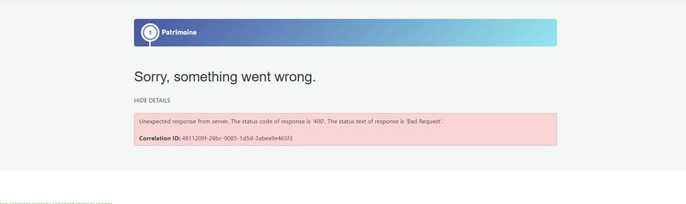

**Solution**:

1. Check with IS or IT teams whether there is any blockage from any new rule or any change deployed to firewall or security.
2. If SharePoint is on-prem, check with SharePoint admin if there are any changes or deployment done lately without updating you.
3. Check with him as well whether there is a newly added load balance or not, and if there is, ask for reconfiguring it or check it.

# The latest files created do not return in search results in **Fotopia Search**

# while it exists in **Document Library,** as per the below snapshot:

**Solution**:

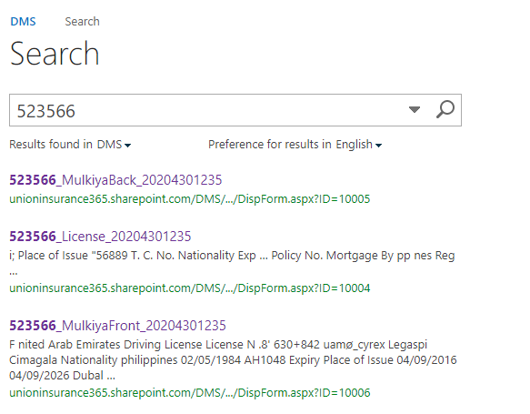The issue here appears only in case the site size became enormously big and the size of the uploaded file as well, which affected the sync of newly added files and slowed down the re-index process. Do as follows according to your SharePoint whether on cloud or prem.

**For SharePoint on cloud:**

1. There is no ETA as the crawling process is dependent on the server.
2. That server resource quota will not impact the crawling process.
3. If files were migrated or uploaded to SharePoint sites, you will have to create a test document inside the folder /document library to make it crawl faster which is the recommended workaround.

Note that ***migrated or uploaded documents*** on average take longer than normal documents to be crawled.

1. There is no automatic way for this workaround in (point 3), as the newly created files crawl faster than migrated files and will help to push the crawling of the entire folder.
2. files are migrated using OR API / CSOM applications, by default they are kept in a different queue for crawling.
3. Re-indexing in such situations will only cause additional issues

**For SharePoint on-prem:**

1. No need to make a re-index solution as this can make issues you just make the last choice.
2. Perform a full crawling process and preferably be at the weekend as if SP site size is very big it will take time maybe two or more days.
3. If the issue still exists, then do re-index only to the specific document library that has this issue only then perform full crawling action from the SharePoint server.

# Issue: After installing viewer I can't open any file from the viewer button in Fotopia search pages

**Solution**:

Fotopia viewer installed on SP but not added its configuration URL to search Item Templates which is responsible on configure each search page as each search page has its item template document.

1. Try to find item templates for all search pages in the following path but if you did not find it check with the one who deploys search pages.
2. On the main page of the site:
3. **Site Settings>>Master pages and page layout>>Display Template folder**
4. Search folder🡪you will find **item templates** files in the Display template folder or any other related names like Fotopia search or item templates
5. Open each item template in notepad++ and go to **the Viewer** configuration section as per the below snapshot.

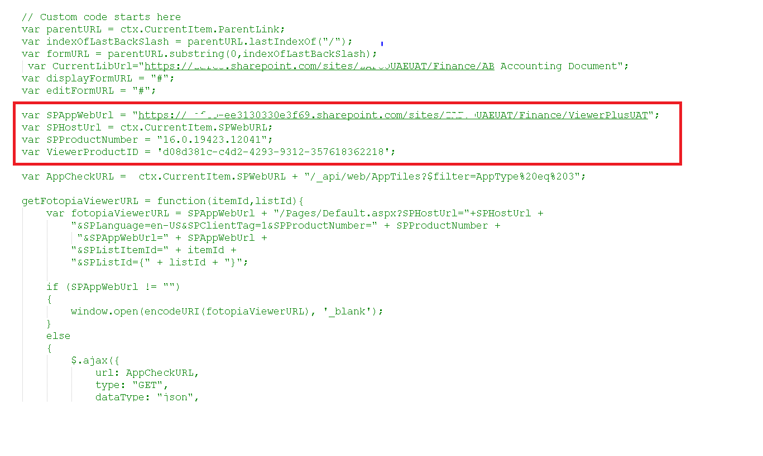

1. Add Viewer configuration info you can get it from the viewer Main URL after installation.
2. Or you can ask one of the Fotopia support team to get it to you.

# While opening any search page face the following error occurs:

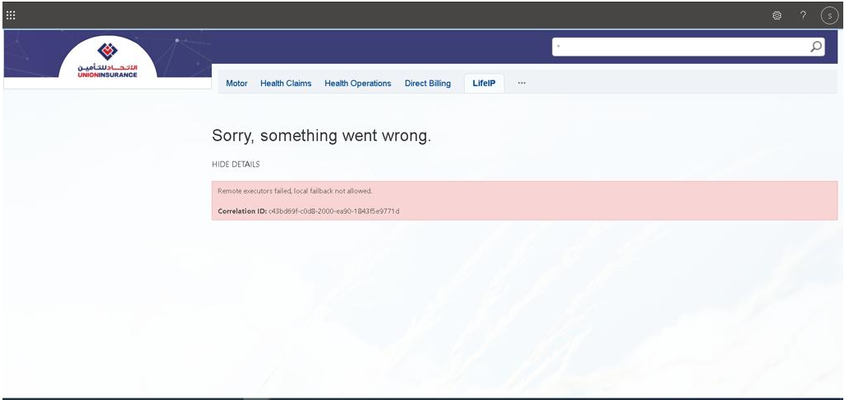

**Solution**

1. Make sure no one changes anything in Item templates or control template files from the concerned team.
2. Check the modified date for the deployment files for any change that happened lately in case no record of it occurred.
3. Apply re-index for the search site.
4. If the issue still exists, raise a ticket to Microsoft support with snapshots and all the details because the issue here will be from their side.

# “Access Denied” message appears after granting permissions to some users

**Solution**

1. If SharePoint is on cloud, wait for Microsoft SharePoint crawling services to start this process depending on SharePoint site size but normally it takes from one day to 3 days.
2. If SharePoint is on-prem, perform the full crawling process manually from the SharePoint server under share point search services in the SharePoint admin portal.